Pokhara University

Level: Bachelor | Semester – Spring | Year : 2007
Programme: BE |  | Full Marks: 100
Course: Engineering Mathematics III |  | Time : 3hrs.

Candidates are required to give their answers in their own words as far as practicable.
The figures in the margin indicate full marks.

Attempt all the questions.

 | - Verify: 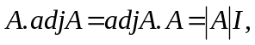 where 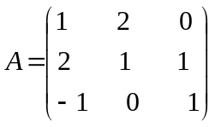  - Check whether the system of linear equations is consistent or not, if consistent solve it by using Gauss elimination method.  x + y + z = 6  x – y + z = 5  3x + y + z = 8 | 8  7
 | - Using the properties of determinant, show that:  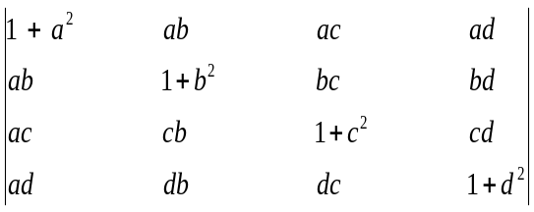 = (1 + a² + b² + c² + d²)  - Define eigen value and vector of the square matrix A. Find eigen values and vectors of the matrix 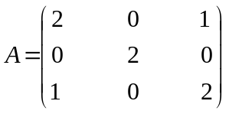  OR  Define linear transformation T : U → V, where U and V are vector space over a field F. A transformation T : R³ → R², which is defined by: T (x, y, z) = (x + y + z, 0) is a linear? If yes / not, describe it. | 7  8
 | - A particle moves along the curve x = t³ + 1, y = t², z = 2t +5. Find the components of its velocity and acceleration at t = 1 in the direction 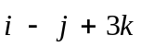.  - Find the divergence and curl of the vector = (xyz, 3x²y, xz² – y²z). | 8  7
 | - State Gauss Divergence theorem. Evaluate 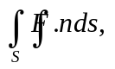where  = (yz, zx, xy), S is the part of the surface x² + y² + z² = 1, which lies in first octant.  - Evaluate the line integral 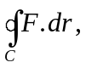 where = (1, xy, yz) and S is the surface x² + y² z, y 0, z 4. | 8  7
 | - Test the convergence and divergence of the series:  - 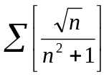  - 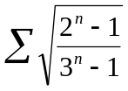  - Find the interval, centre, and radius of convergence of the series  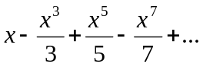  OR  Find the expansion of the given function by using Maclaurin expansion 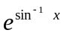. | 3  4  8
 | - Find the Fourier series of f(x) = 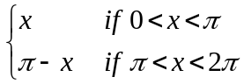  - Find the Fourier series of f(x) = x² – 2 if -2 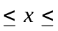2. | 7  8
 | Attempt all the questions:  - Check whether the given transformation is linear or not  T : R² → R³ defined by T (x, y) = (x, y, xy)  - Test the convergent and divergent of the series 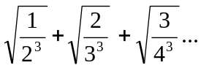  - Is the function odd, even or neither odd nor even  sinh 2x  - If = cosnt 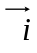 + sinnt . Show that × 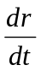 = 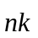.  - Find a unit vector normal to the surface x²y + 2xz = 4 at (2₁ – 2, 3). | 5×2

